**Device Discovery**

Contents

**Introduction** 2

**Requirements** 2

**Adding a New Device** 2

Configuring a Discovery Profile 2

Running Auto Discovery 4

**SNMP Discovery** 4

Checking and Listing Device IDs 4

SNMP Device Discovery 5

SNMP Interface Discovery 8

**Device Group Assignment** 11

Location Based Assignment 11

CPU Based Assignment 12

## Introduction

Device Discovery is a process of locating any device or interface connected in a network. This process provides detailed hardware and software information and helps an administrator/user to manage all the devices in the network. To discover a device, it has to be first added to the network.

## Requirements

* Device IP Address and DNS name
* Technology (IPMPLS/NGE/CVPN)
* Device Group list where the device is to be added
* All the interfaces that have to be added
* System and Interface level Metrics

## Adding a New Device

### Configuring a Discovery Profile

The process of Auto Discovery requires adding of a new device as given below:

1. Go to **Administration** tab found on the left top corner of the screen.
2. In the navigation pane present on the left, click on **Manage Disco Profiles** found under **Discovery Actions** label to display a list of profiles as shown in the screenshot below.

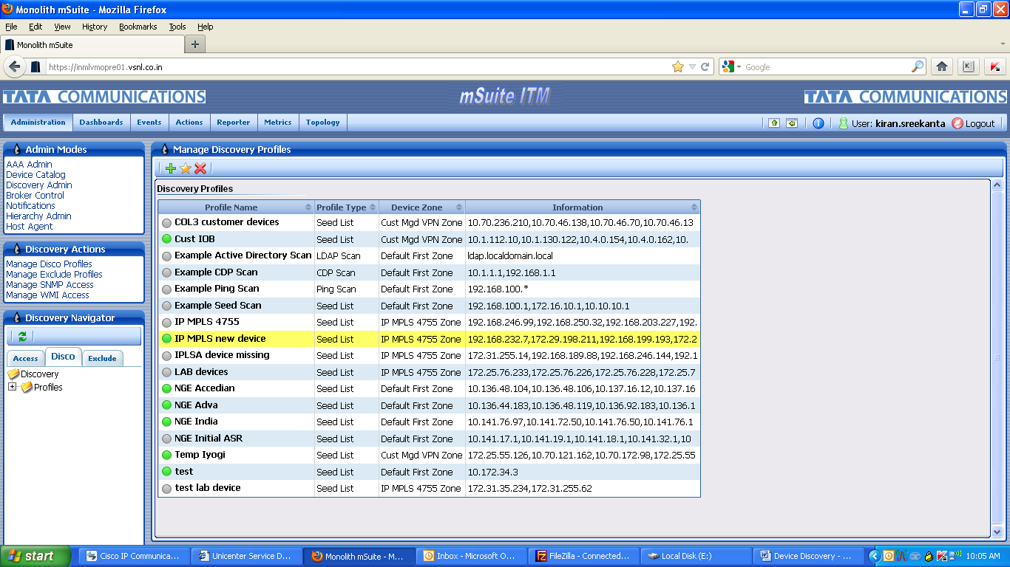

1. A device can be added under any category based on requirements. Select a required profile from the list (example highlighted in the screenshot above: **IP MPLS new device**).
2. Click on **Modify** icon to display the **Manage Discovery Profiles** window as shown in the screenshot below.

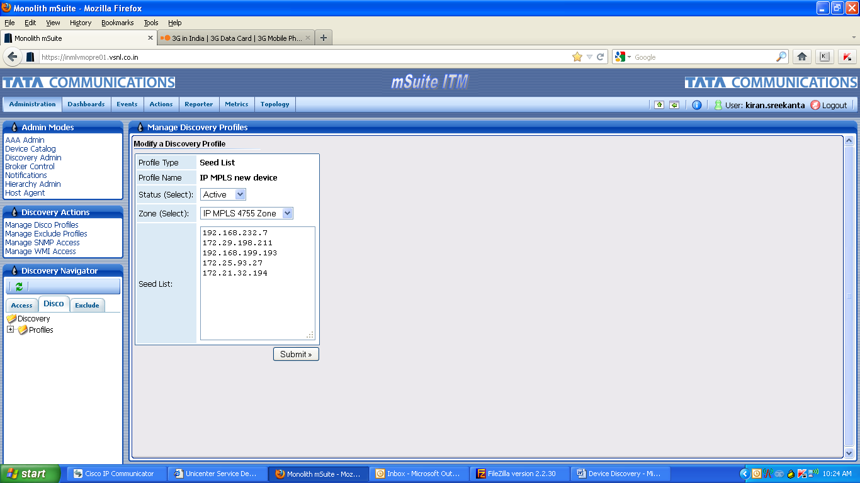

1. Add IP Addresses of new devices in the **Seed List** box.
2. Click on **Submit** button to navigate to **Broker Scheduled Jobs** window as shown in the screenshot below. This confirms that the new devices have been added and that the configuration of the discovery profile has been completed.

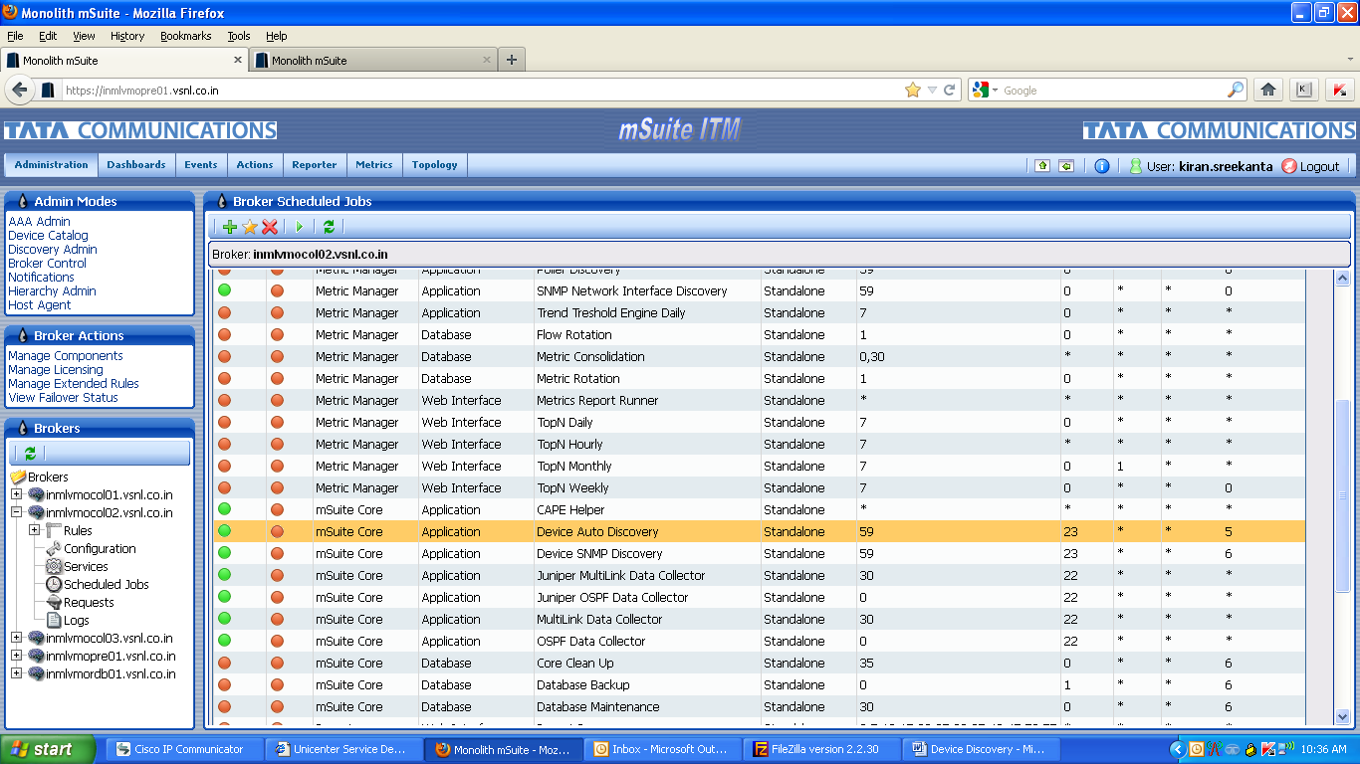

### Running Auto Discovery

Once the new devices have been added, they need to be located in the network by performing **Auto Discovery** as given below:

1. Go to **Administration** tab found on the left top corner of the screen.
2. In the navigation pane present on the left, click on **Broker Control** found under **Admin Modes** label.
3. Select the required collection server i.e. **Scheduled Jobs** found under **Brokers** label.
4. Select **Device Auto Discovery** from **Broker Scheduled Jobs** window.
5. Click on the **Run** button (with ►sign) found on the left top corner to complete the **Auto Discovery** process.

## SNMP Discovery

### Checking and Listing Device IDs

Each device is associated with a Device ID. This Device ID is paired with a Zone ID to perform SNMP Device Discovery. The Device IDs for all discovered devices can be located as given below:

1. Go to **Metrics** tab found at the top of the screen.
2. In the navigation pane present on the left, select **Device Monitoring** under **Metric Modes** labelas shown in the screenshot below.

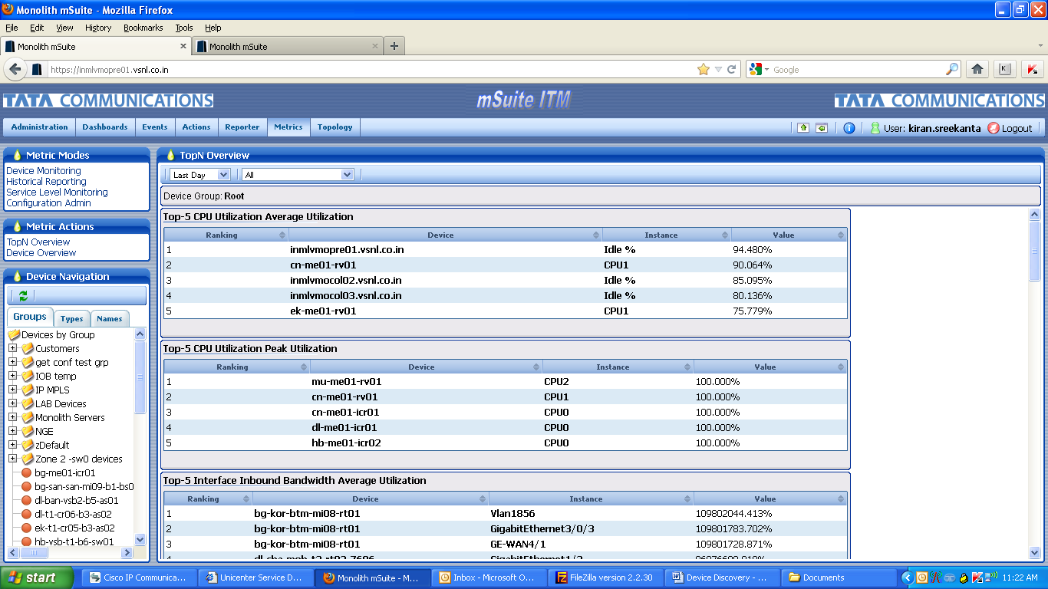

1. Click on **Groups** tab found under **Device Navigation** label to display devices by groups. The newly added devices do not fall under any of these groups. Instead they get populated after the list of groups (example: **bg-me01-icr01**).
2. Hover the mouse on a newly added device that is listed after the groups. The Device ID for this device gets displayed at the left bottom corner of the screen as shown in the screenshot below.

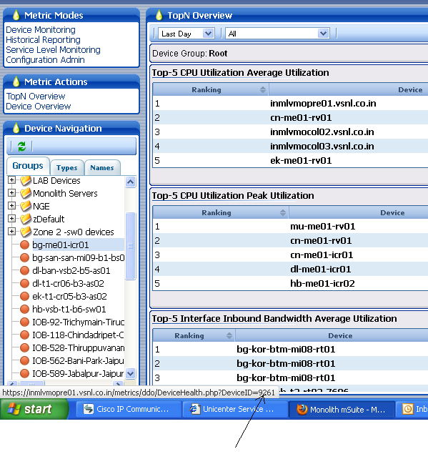

1. Similarly, note all the Devices IDs for all the other newly added devices to perform SNMP Discovery.

### SNMP Device Discovery

To perform SNMP Device Discovery, follow the instructions given below:

1. Go to **Administration** tab found on the left top corner of the screen.
2. In the navigation pane present on the left, click on **Broker Control** found under **Admin Modes** label.
3. Select the required collection server i.e. **Scheduled Jobs** found under **Brokers** label as shown in the screenshot below.

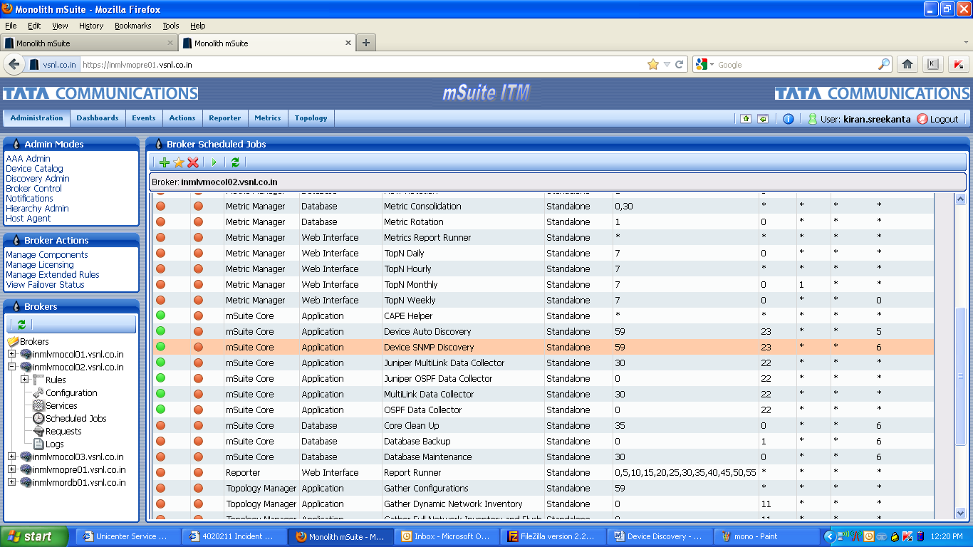

1. Select **Device SNMP Discovery** and click on the **Modify** icon to display **Modify a Scheduled Job** window as shown in the screenshot below.

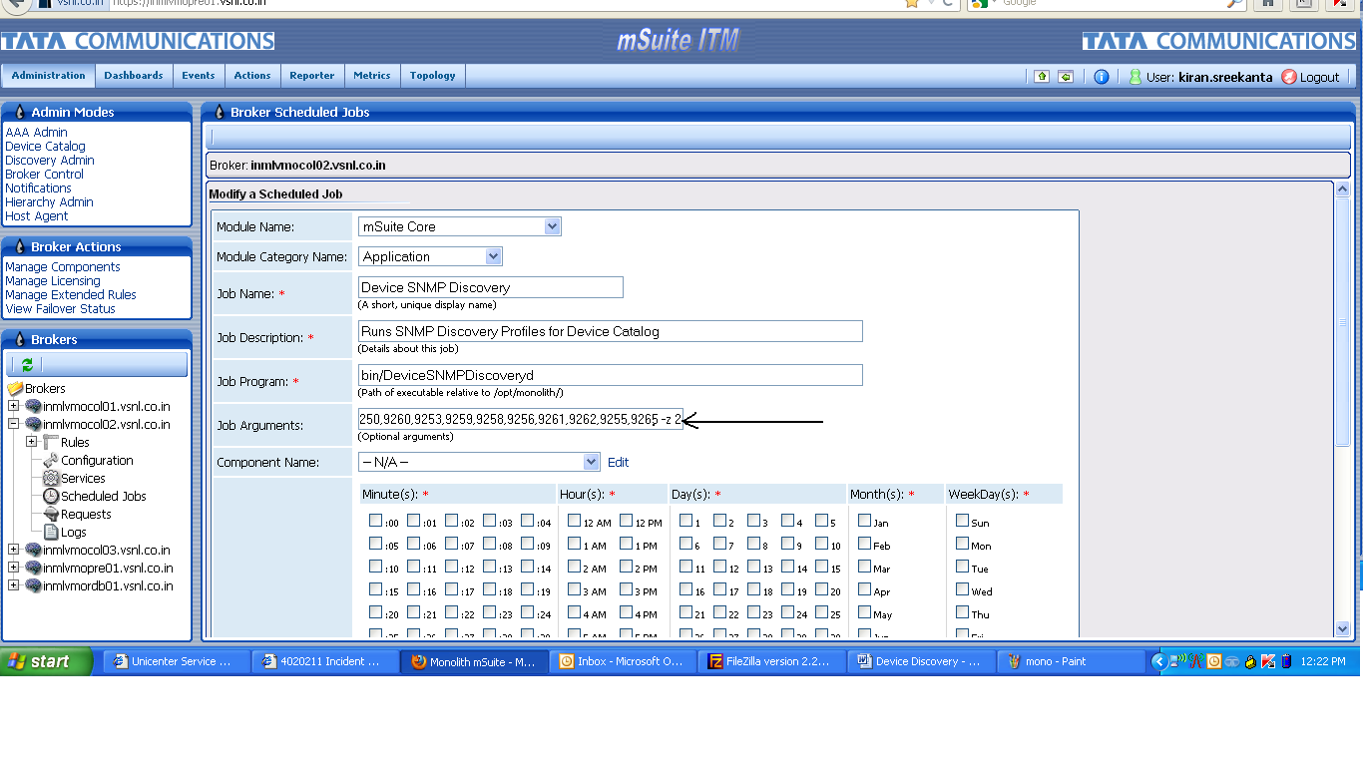

1. In the **Job Arguments** text box, add the Device IDs and Zone ID that were noted earlier and click on **Submit** button as shown in the screenshot above.
2. To check if the SNMP Discovery has been completed successfully, follow the steps given below:
3. Go to **Device Catalog** found under **Admin Modes** label present in the navigation pane on the left, as shown in the screenshot below.

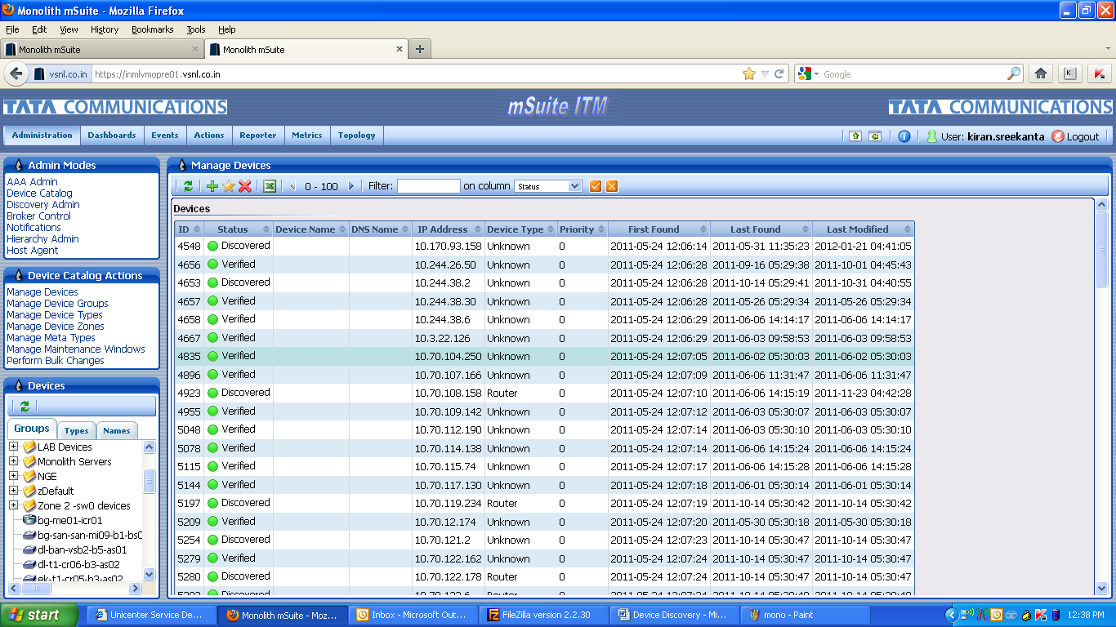

1. Click on any one of the newly added devices listed in the **Groups** tab of navigation pane. If SNMP profile information, device name, IP address, etc. have been populated then the device has been discovered properly.

Following is a screenshot showing information before the device is discovered:

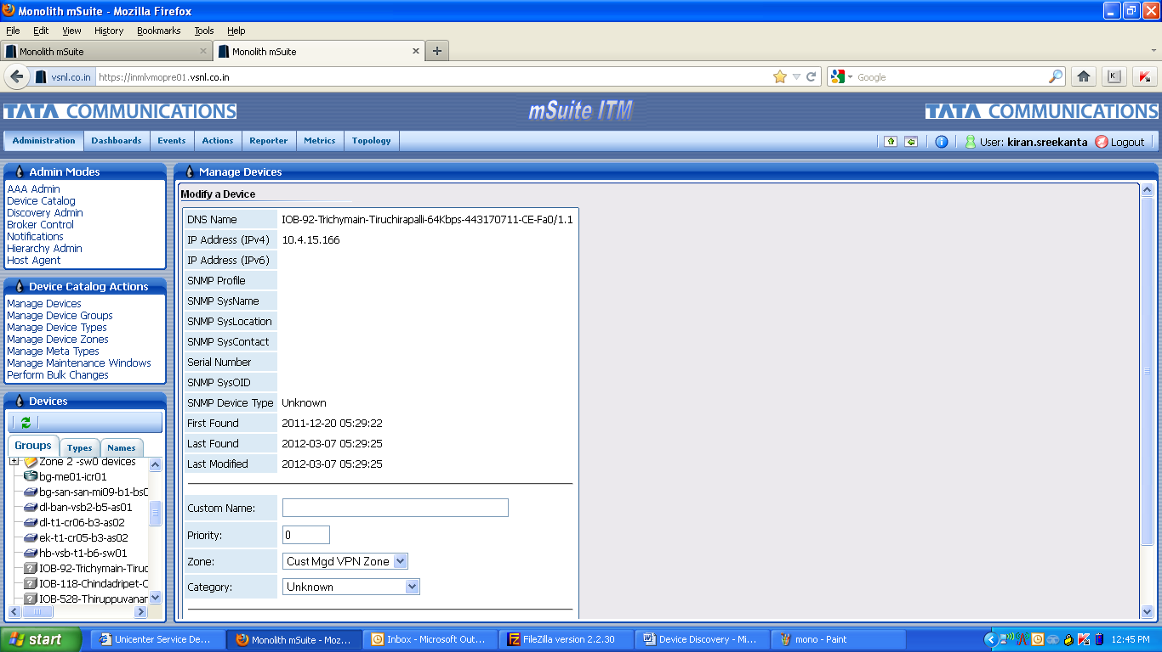

Following is a screenshot showing information after the device is discovered:

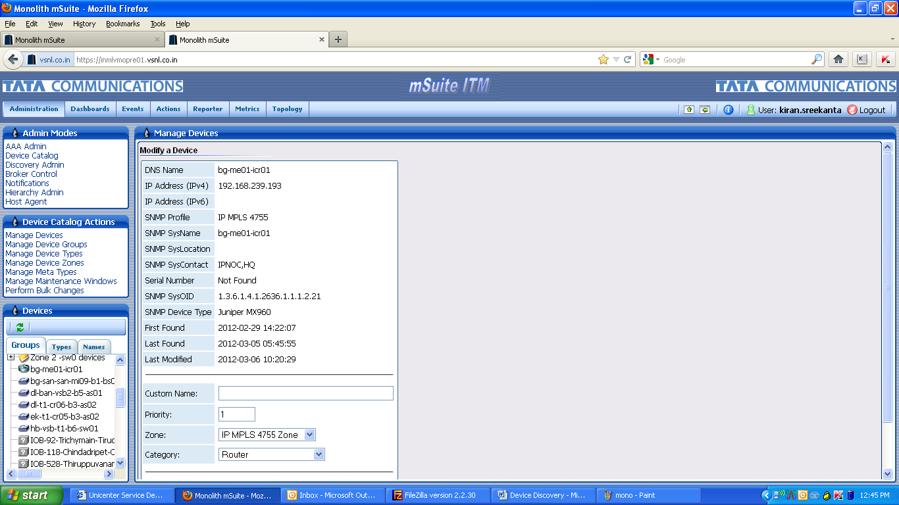

### SNMP Interface Discovery

To perform SNMP Interface Discovery, follow the instructions given below:

1. Go to **Administration** tab found on the left top corner of the screen.
2. In the navigation pane present on the left, click on **Broker Control** found under **Admin Modes** label.
3. Select the required collection server i.e. **Scheduled Jobs** found under **Brokers** label as shown in the screenshot below.

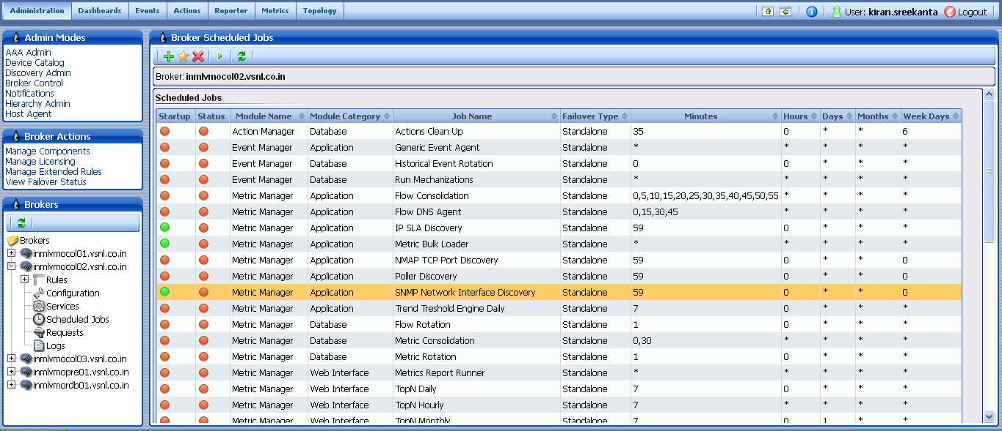

1. Select **SNMP Network Interface Discovery** and click on the **Modify** icon to display **Broker Scheduled Jobs** window as shown in the screenshot below.

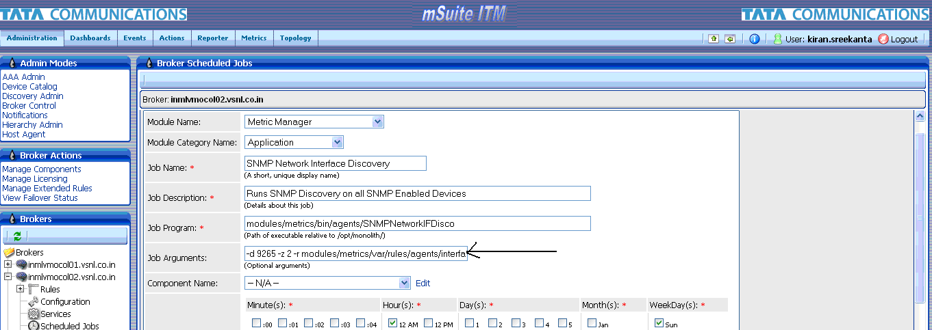

1. In the **Job Arguments** text box, add the Device ID, Zone ID that were noted earlier as shown in the screenshot above.
2. Select **Component Name** by using the drop down menu and click on **Submit** button as shown in the screenshot below.

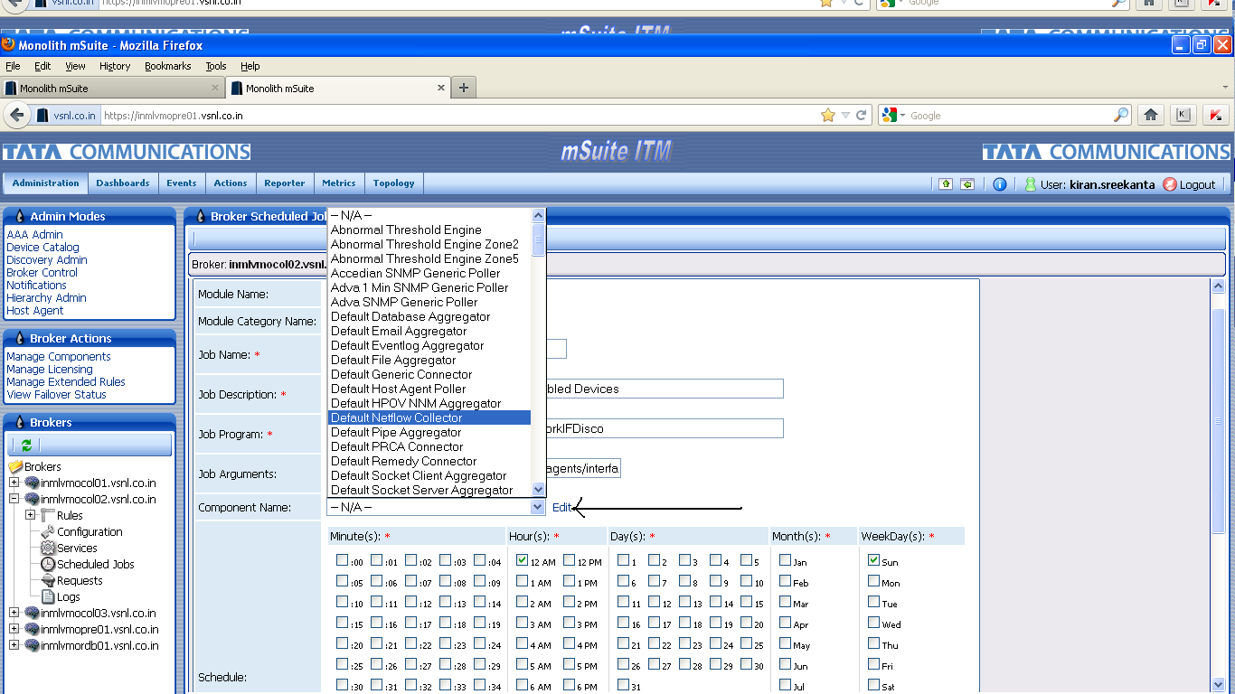

1. To check if the components have been added successfully, follow the steps given below:
2. Go to **Metrics** tab found on the left top corner of the screen.
3. In the navigation pane present on the left, click on **Configuration Admin** found under **Metric Modes** label.
4. Click on **Manage Polling** found under **Metric Actions** label present in the navigation pane on the left. This window displays all the devices as shown in the screenshot below.

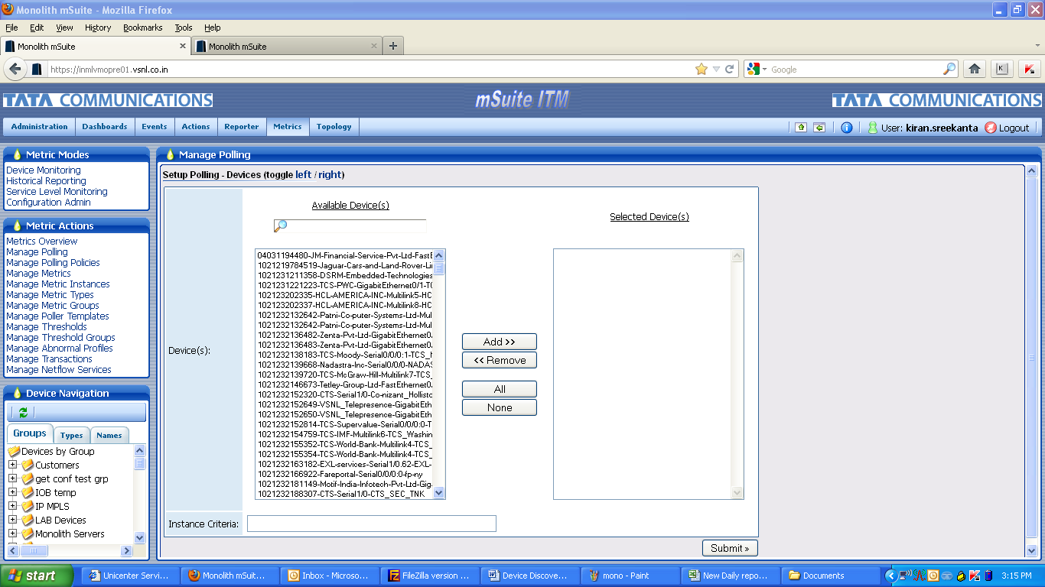

1. Locate all newly added devices by typing in the Search box and click on **Add>>** button as shown in the screenshot below.

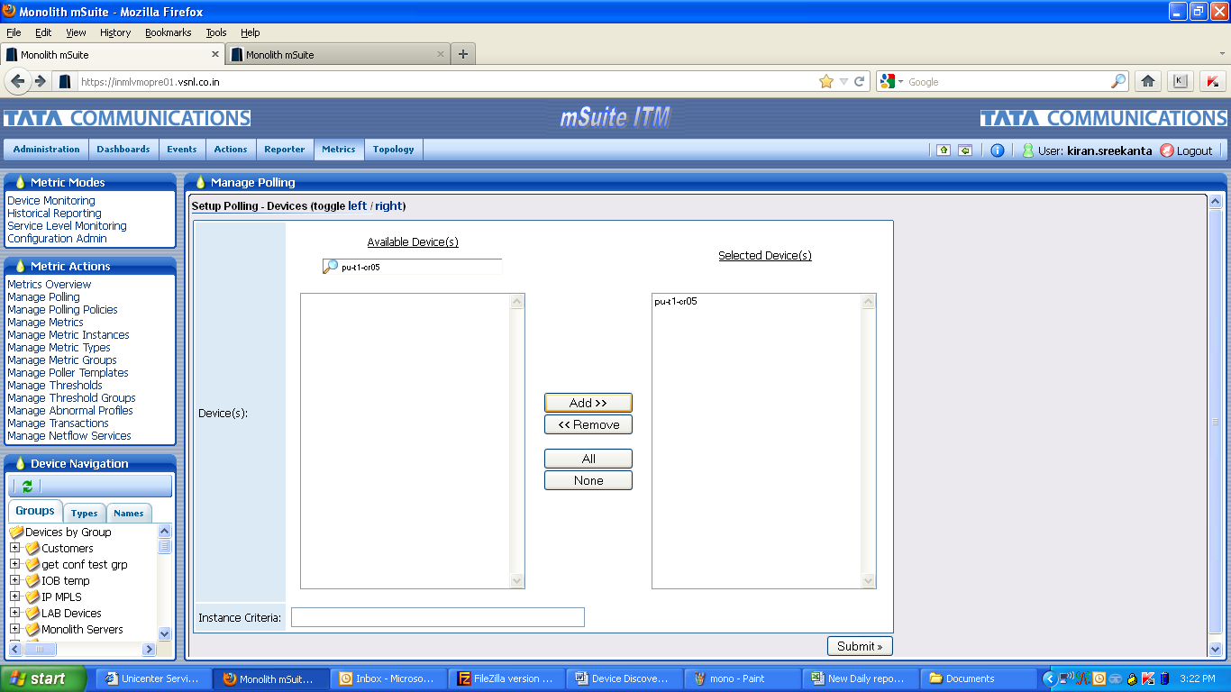

1. The added devices appear in the **Selected Device(s)** box present on the right. After all devices have been added, click on **Submit** button to display the following window:

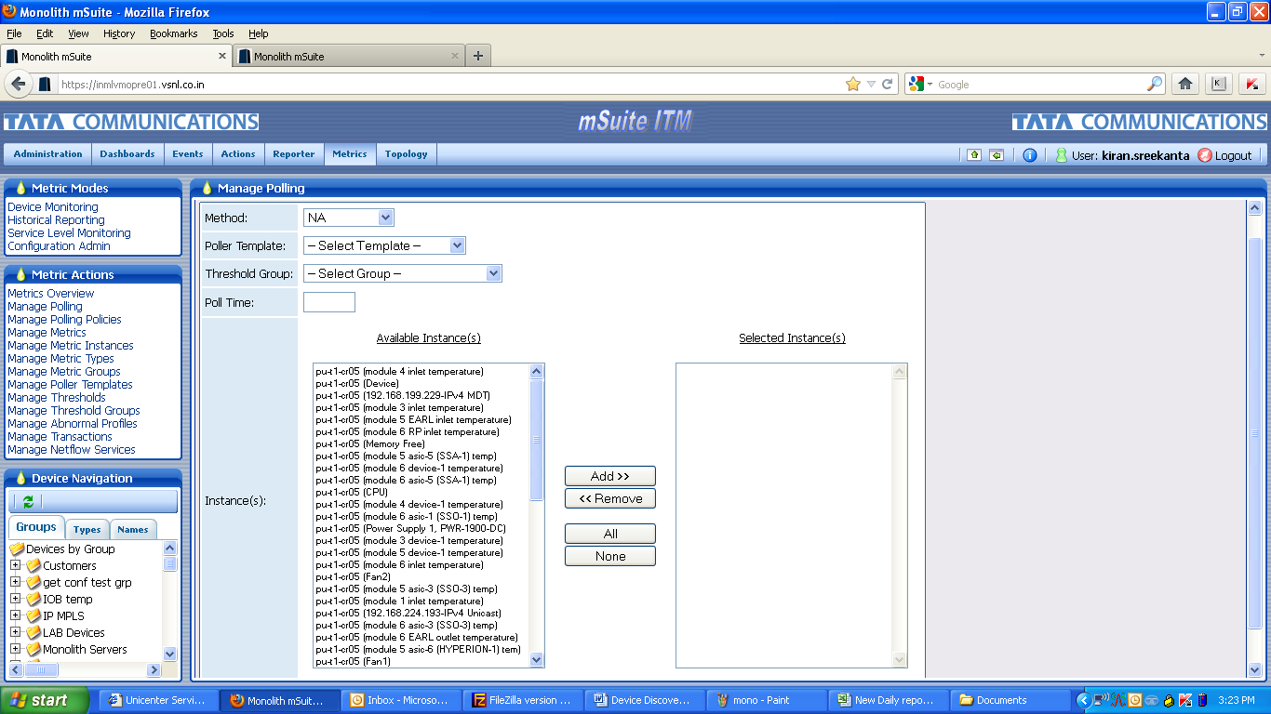

1. Select values for **Method**, **Poller Template**, and **Threshold Group** by using the drop down menu. Provide **Poll Time** of the devices. Also select the required instances from the list of all the **Available Instance(s)** that pertain to the devices and click on **Add>>** button.
2. The addition of devices and their respective instances completes the **SNMP Interface Discovery**.

## Device Group Assignment

### Location Based Assignment

To assign devices based on location, follow the instructions given below:

1. Go to **Administration** tab found on the left top corner of the screen.
2. In the navigation pane present on the left, click on **Device Catalog** found under **Admin Modes** label.
3. Select **Manage Device Groups** from **Device Catalog Actions** label. This redirects to a window that populates a list of groups as shown in the screenshot below. Based on the requirements a new device can be added to any category.

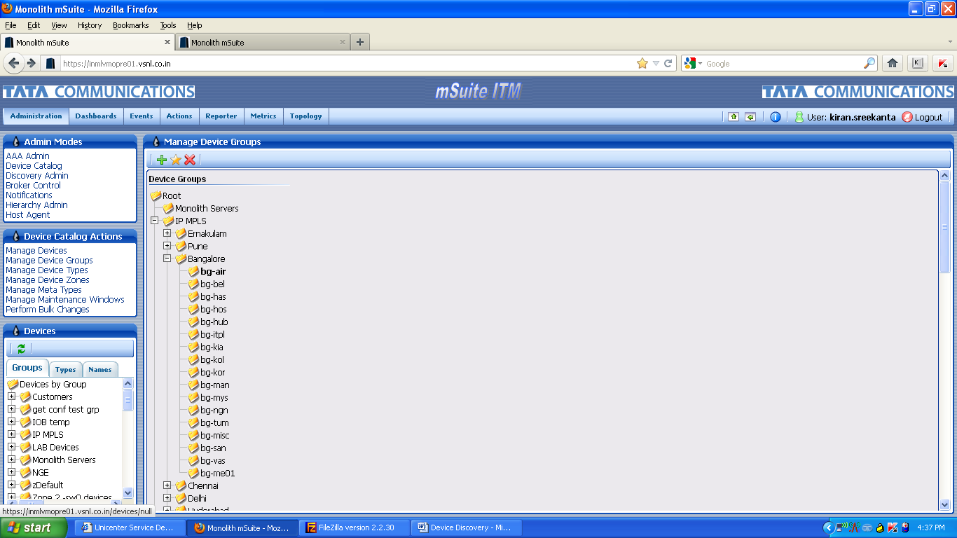

1. Select a group under any location to which the device has to be added and click on the **Modify** icon. This redirects to the following window:

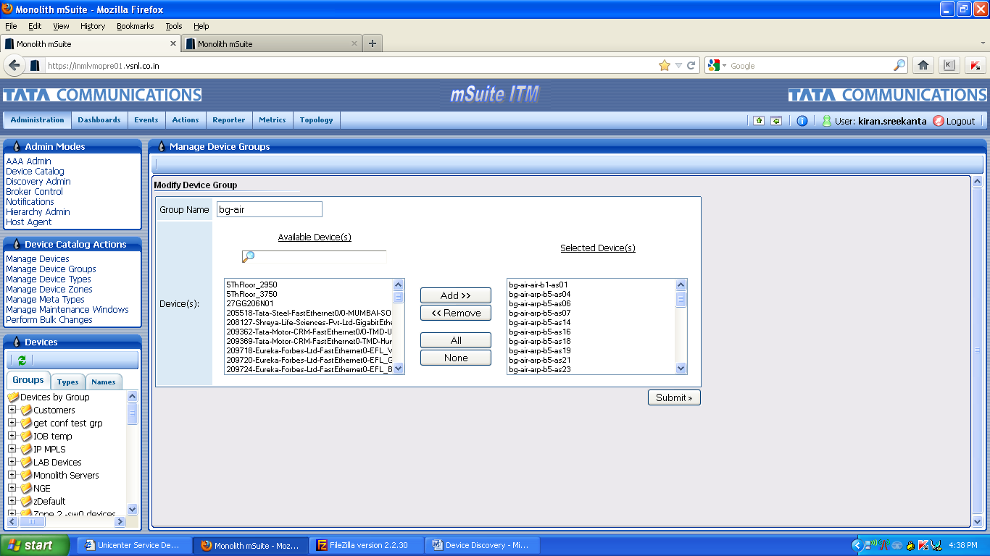

1. Select a device from **Available Device(s)** list and click on **Add>>** button. All the newly added devices get displayed in the **Selected Device(s)** box to the right.
2. Click on **Submit** button to add the device to the selected location.

### CPU Based Assignment

To assign devices based on CPU, follow the instructions given below:

1. Go to **Administration** tab found on the left top corner of the screen.
2. In the navigation pane present on the left, click on **Device Catalog** found under **Admin Modes** label.
3. Select **Manage Device Groups** from **Device Catalog Actions** label. This redirects to a window that populates a list of **High CPU** and **Normal CPU** groups as shown in the screenshot below. Based on the requirements a new device can be added to any category.

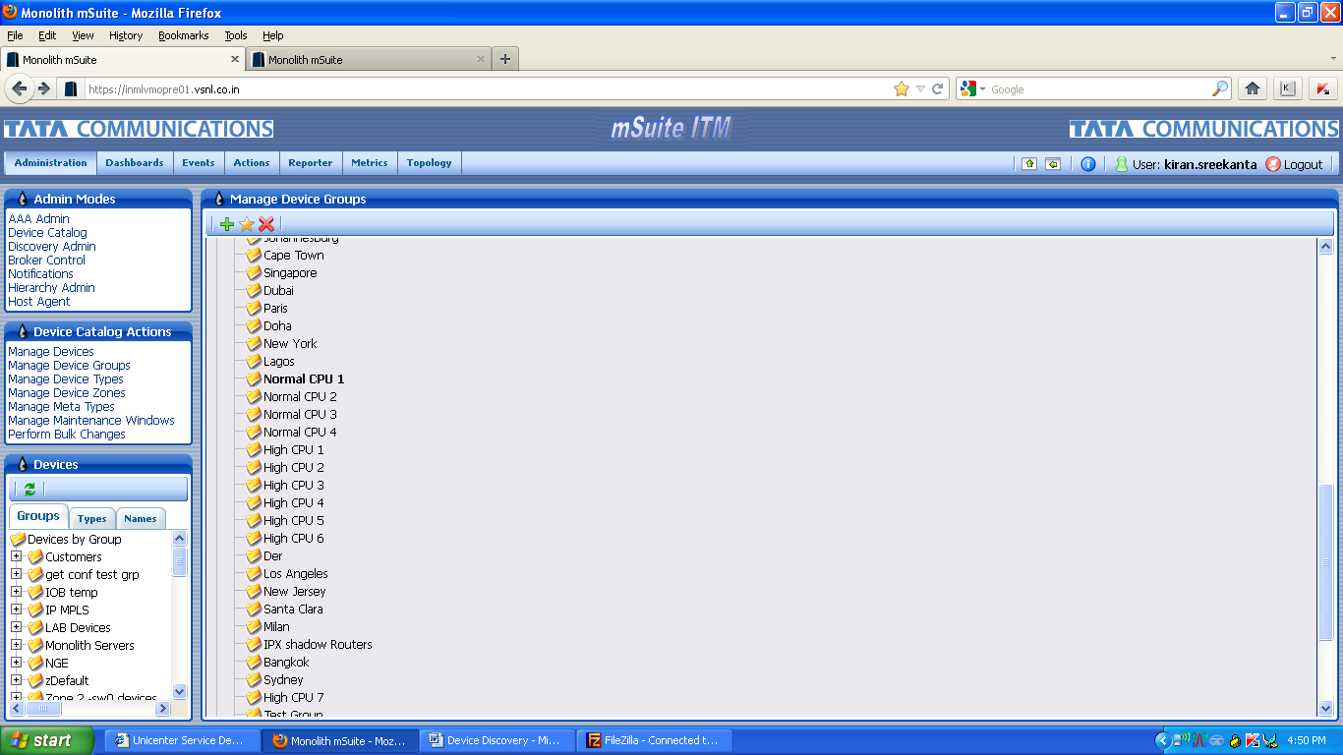

1. Select a CPU group to which the device has to be added and click on the **Modify** icon. This redirects to the following window:



1. Select a device from **Available Device(s)** list and click on **Add>>** button. All the newly added devices get displayed in the **Selected Device(s)** box to the right.
2. Click on **Submit** button to add the device to the selected CPU group.